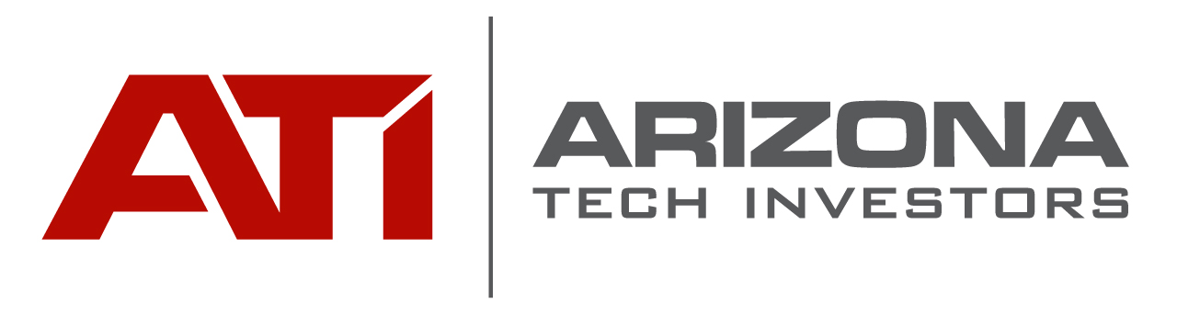

Investment Opportunity Overview

Name of Company:______________________________________

Name of Contact______________________ email address:___________________________

Date:_______________________________

Name of Round:______________________ Amount of Round:____________________

Does the Company have a signed Term Sheet?

Yes_____

No_____

If YES
- Attach signed Term Sheet to this form

- Name of Lead Investor________________________________

- Amount of Round Remaining Available___________________

If NO
- Does the Company have proposed Terms?

Yes______

No_______

If Yes
- Attach your terms

- How negotiable are these terms?

  - Fully___________

  - Partially________

  - Not at all_______

